**IT111 – INTRODUCTION TO COMPUTING**

**PERSONAL WEBSITE DEVELOPMENT**

Name: Dave Nathaneil M. Pequero

Website Active Link: <https://pequero-davenathaneil-t218.netlify.app/>

*(Screenshots of your final website with 3 webpages:* ***Home Page, ITIII Blog Entries Page and Flex Page.)***

*(add labels in your screenshots)*

*Home page:*

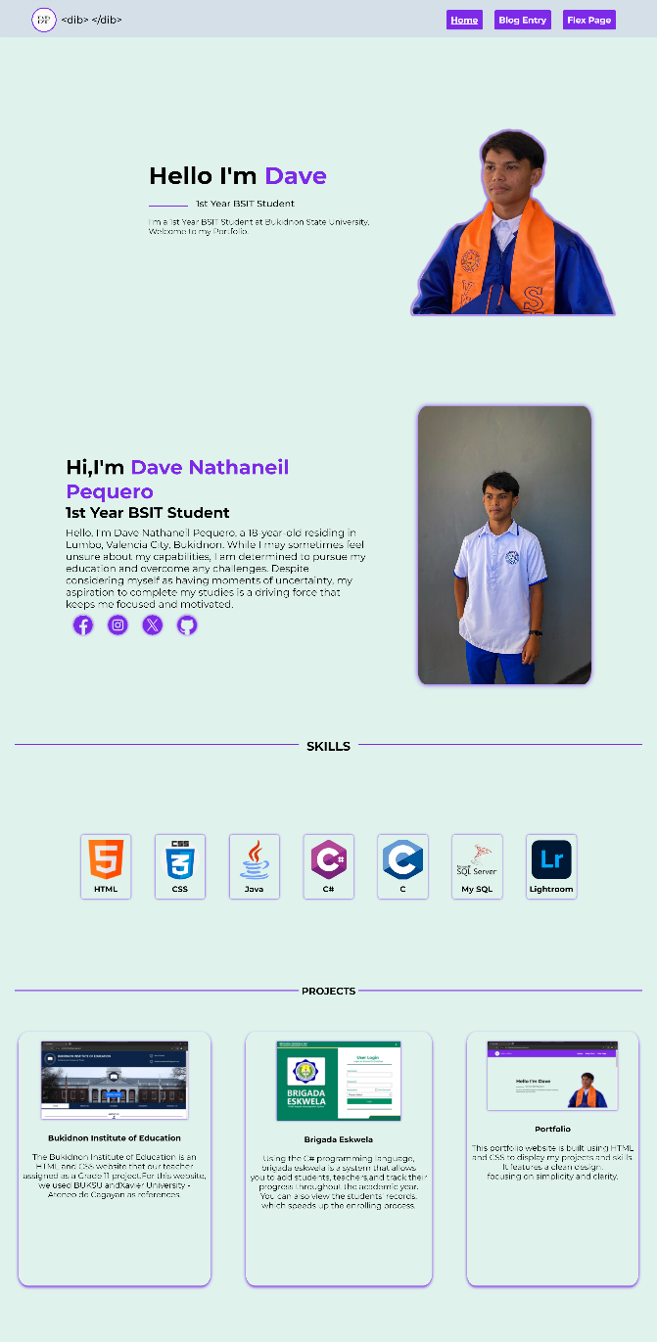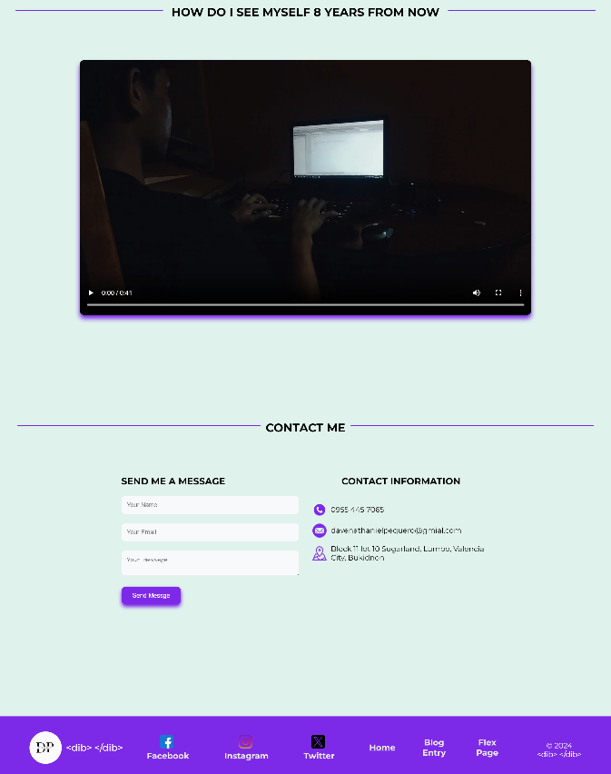

23

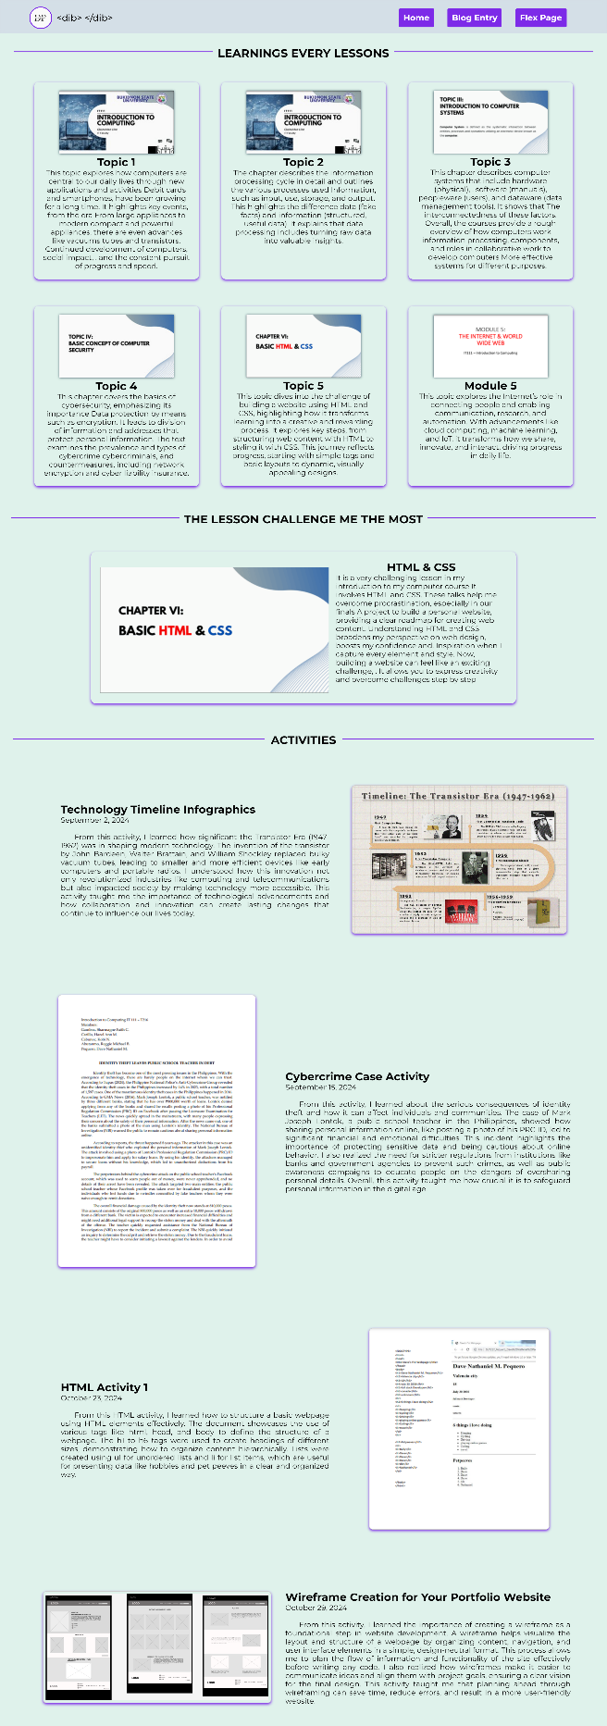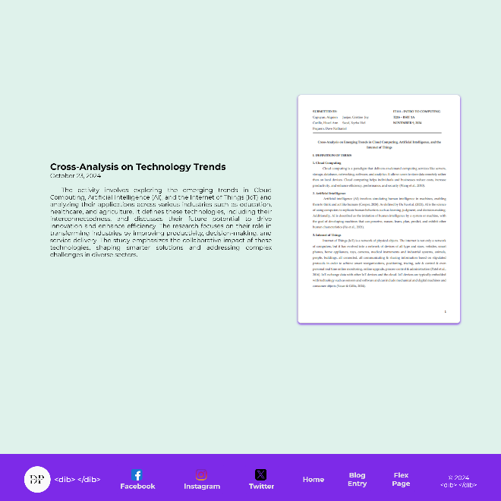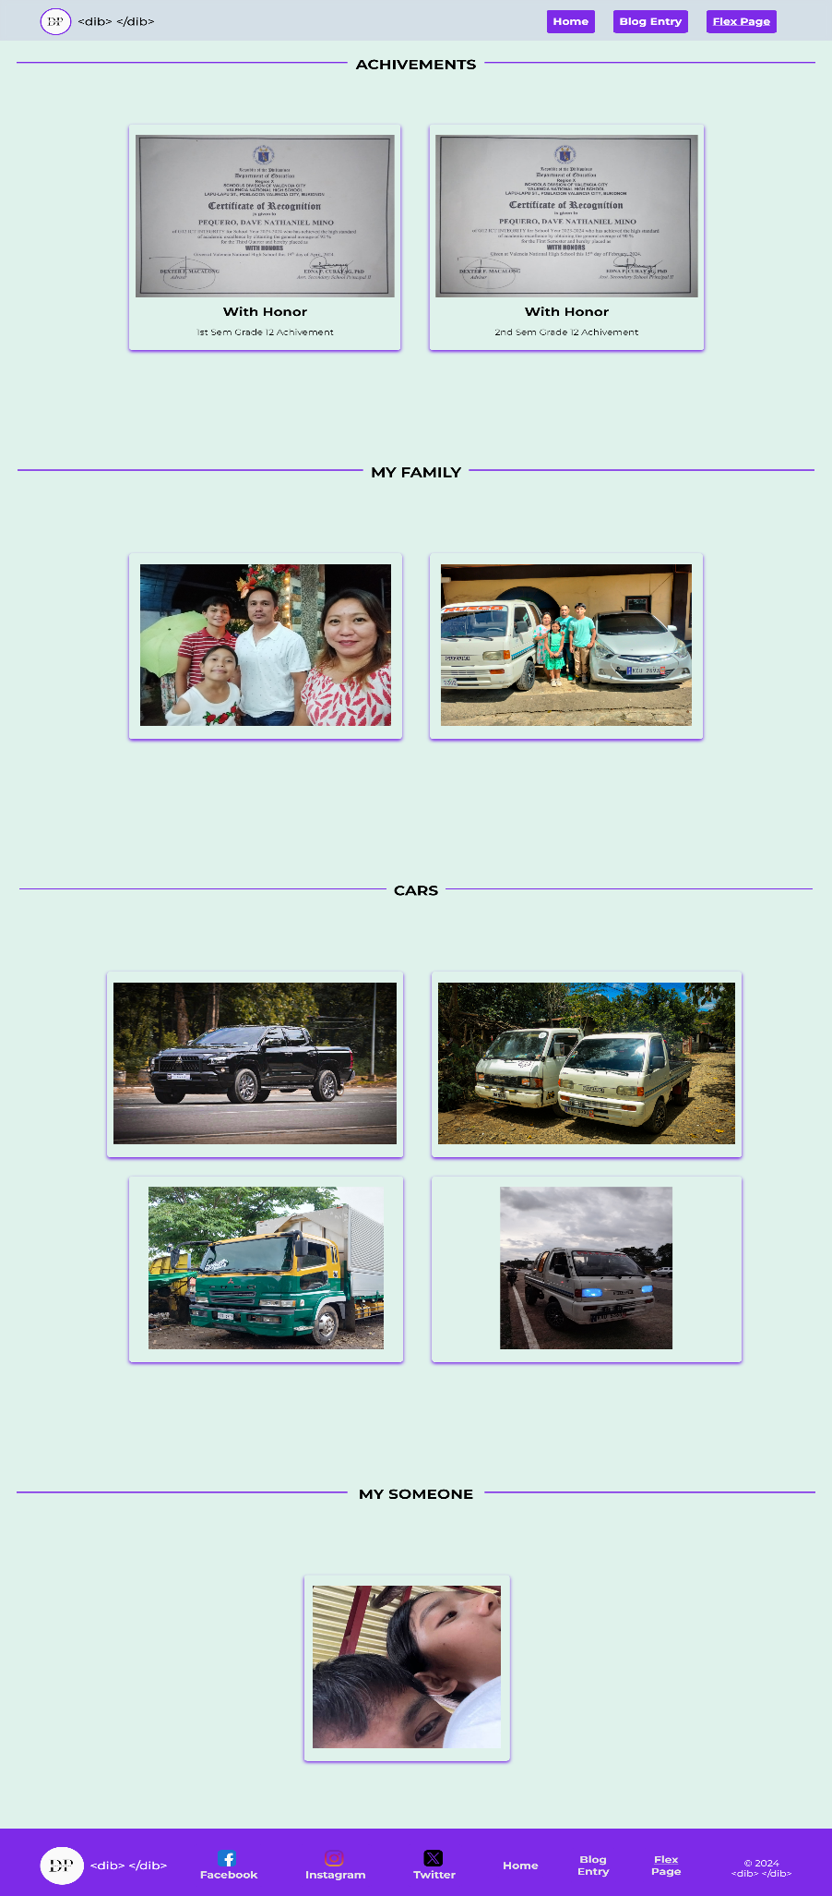

*Blog Page:*

*Flex Page:*